Project: MESH GATT BEARER

Lowe Level Design Document

Table of Contents
1 Introduction 4
1.1 Purpose 4
1.2 Terminology 5
1.3 References 5
2 Scope………………………………………………………………………………………………………………………...6
3 Task List and Effort Estimation 7
4 System Architecture 8
5 License Details 13
6 Development Environment 14
6.1 HW Detail 14
6.2 Development host 14
6.3 Build tools and IDE 14
7 Configurations Supported 15
7.1 Compile time configuration 15
7.2 Initialization configuration 15
7.3 Runtime configuration 15
8 Application API Library 16
8.1 Structures 16
8.1.1 _attribute,RemDevInfo…………………………………………………………………………………....16
8.2 Enums and Macros 17
8.2.1 PRIMARY_SERVICE 0x2800 17
8.2.2 DESCRIPTOR 0x2902……………………………………………………………………………………...17
8.2.3 REG_CHARACTERISTICS 0x2803 17
8.2.4 PROVISION_SERVICE 0x18273…………………....................................................................................17
8.2.5 PROXY_SERVICE 0x1828…………………………………………………………………….................17
8.2.6 PROVISIONING_DATA_IN 0x2ADB 17
8.2.7 PROVISIONING_DATA_OUT 0x2ADC…………………………………………………………………..17
8.2.8 PROXY_DATA_IN 0x2ADD……………………………………………………………………………...17
8.2.9 PROXY_DATA_OUT 0x2ADE……………………………………………………………………………17
8.3 Callback function declarations 18
8.3.1 gatt_service_cb()…………………………………………………………………………..…………..…..18
8.3.2 global_cb()……………………………………………………………………………..……………..…….18
8.3.3 gap_cb()……………………………………………………………………………………………………..19
8.4 Function Declarations 20
8.4.1 reg_provisioning_service()………………………………………………………………………………..20
8.4.2 reg_proxy_service()………………..……………….………………………………………………………21
8.4.3 register_prov_dataout_discriptor()………...……………………………………………………………21
8.4.4 register_proxy_dataout_discriptor()…………………………………………………………………….21
8.4.5 register_prov_mesh_data_in_char()……………………………………………………………………..22
8.4.6 register_prov_mesh_data_out_char()…………………………………………………………………22
8.4.7 register_proxy_mesh_data_in_char()……………………………………………………………………..23
8.4.8 register_proxy_data_out_char()…………………………………………………………………………...23
8.4.9 handle_start_adv()…………………………………………………………………………………………..23
8.4.10 set_scan_resp()…………………………………………………………………………………………..….23
9 Appendix 24

Revision History
S. No | Date | Version | Change | Author | Reviewer | Approver
1. | 07/09/2023 | 1.0.1 | Design doc for GATT Bearer | Sowmya Shetty  Harshitha N | Sachin chougale

Introduction

Purpose
The purpose of the BLE Mesh GATT bearer is to address the limitation of devices that do not support advertising in a mesh network. This component serves as a critical bridge, enabling these non-advertising-capable devices to actively participate in the network. The GATT bearer layer facilitates the exchange of proxy Protocol Data Units (PDUs) within the mesh network.

Service and Characteristics
- Mesh Provisioning Service:
It is instantiated as a "Primary Service" of the BLE Mesh GATT bearer. It is designed to facilitate the provisioning of devices into a mesh network.
Characteristics of the Mesh Provisioning Service:
- Mesh Provisioning Data In
- Mesh Provisioning Data Out

- Mesh Proxy Service:
It is instantiated as a "Primary Service" and is responsible for enabling communication between a server and a client using Proxy PDUs.
Characteristics of the Mesh Proxy Service:
- Mesh Proxy Data In
- Mesh Proxy Data Out

Terminology
Term | Explanation
PDU | Protocol Data Unit.
GATT | Generic Attribute Profile, defines the structure and behavior of services and characteristics
UUID | Universally Unique Identifier
BT | Bluetooth

References
- Bluetooth SIG specification for BLE Mesh:
https://www.bluetooth.com/specifications/specs/mesh-profile-1-0-1/
2. Bluetooth Core Specification
https://www.bluetooth.com/specifications/specs/core-specification-5-3/

Scope
This document provides a detailed description of the Ble Mesh GATT bearer. It covers detail about Proxy node, Provisioning, Services, Characteristics and associated UUIDs.

Task List and Effort Estimation

System Architecture

The below diagram represents the BLE Mesh profile system architecture. The bearer layer defines how network messages are transported between nodes. There are two Types of bearers defined, the advertising bearer and the GATT bearer. In this document we are focusing on the GATT Bearer.

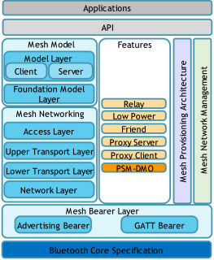

GATT BEARER
The GATT bearer is provided to enable devices that are not capable of supporting the advertising bearer to participate in a mesh network. The GATT bearer uses the Proxy protocol to transmit and receive Proxy PDUs between two devices over a GATT connection.

The GATT bearer defines two roles,
- GATT Bearer Client
- GATT Bearer Server

It defines two GATT-based services,
- The Mesh Provisioning Service
The Mesh Provisioning Service shall be instantiated as a Primary Service.
The Service UUID shall be set to Mesh Provisioning Service.
It allows a Provisioning Client to provision a Provisioning Server to allow it to participate in the mesh network.
A provisioning bearer layer enables the transportation of Provisioning PDUs between a Provisioner and an unprovisioned device. PB-GATT is a provisioning bearer used to provision a device using Proxy PDUs to encapsulate Provisioning PDUs within the Mesh Provisioning Service.
Mesh Provisioning has two characteristics,
- Mesh Provisioning Data In characteristic
The Mesh Provisioning Data In characteristic can be written to send a Proxy PDU message containing Provisioning PDU to the Provisioning Server.
The Mesh Provisioning Data In characteristic is identified using the UUID Mesh Provisioning Data In.
- Mesh Provisioning Data Out characteristic
The Mesh Provisioning Data Out characteristic can be notified to send a Proxy PDU message containing Provisioning PDU from a Provisioning Server to a Provisioning Client.
The Mesh Provisioning Data Out characteristic is identified using the UUID Mesh Provisioning Data Out.

- Mesh proxy service
The Mesh Proxy Service shall be instantiated as a Primary Service.
The Service UUID shall be set to Mesh Proxy Service.
The Mesh Proxy Service is used to enable a server to send and receive Proxy PDUs with a client.
Mesh Proxy has two characteristics,

- Mesh Proxy Data In
The Mesh Proxy Data In characteristic is used by the client to send Proxy PDUs to the server.
The Mesh Proxy Data In characteristic is identified using the UUID Mesh Proxy Data In.

- Mesh Proxy Data Out
The Mesh Proxy Data Out characteristic is used by the server to send Proxy PDUs to the client.
The Mesh Proxy Data Out characteristic is identified using the UUID Mesh Proxy Data Out.

PROVISIONING
Provisioning is a process of adding an unprovisioned device to a mesh network, managed by a provisioner.

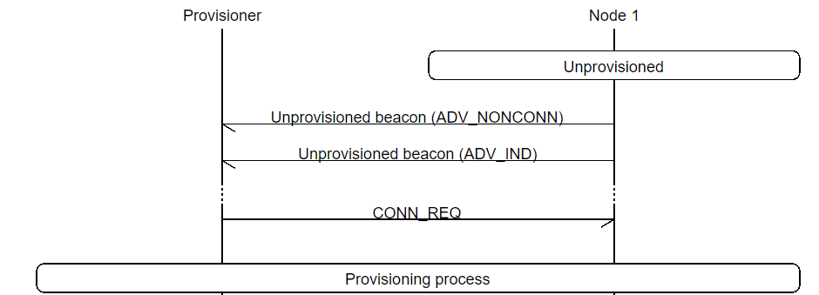

The provisioning procedure consists of five phases:
- Beaconing
- Invitation
- Exchange public keys
- Authentication
- Distribution of provisioning data

- The provisioner represents the network owner and is responsible for adding new nodes to the mesh network.
- The provisionee is the device that gets added to the network through the Provisioning process. Before the provisioning process starts, the provisionee is an unprovisioned device.
- When the PB-GATT bearer is used by the unprovisioned device, a GATT service called the Mesh Provisioning Service supports the overall provisioning procedure and interactions with the provisioner.
- The device first advertises both non-connectable and connectable Unprovisioned Device beacons. The non-connectable beacon is used for PB-ADV. The connectable beacon is used for PB-GATT, and it also includes the Bluetooth mesh Provisioning Service UUID.
- It is discovered by the provisioner through the standard Bluetooth Low Energy scan procedure.
- Immediately after the provisioner has connected to the device, it stops advertising both beacons. The provisioning process starts.
- The provisioner initiates the Provisioning process by sending a Provisioning invitation.
- The Unprovisioned device automatically responds to the invite by presenting a list of its capabilities, including the supported Out of Band Authentication methods and algorithms.
- Before the provisioning process can begin, the provisioner and the unprovisioned device exchange public keys, either in-band or Out of Band (OOB).
- This allows the user to confirm that the device the provisioner connected to is actually the device they intended, and not a malicious third party.
- After the device has been successfully authenticated, the provisioner transfers the Provisioning data that includes Unicast address, network key, IV index, Network flags, Key refresh, IV update.
- These above PDU are sent through the proxy protocol through a GATT bearer.

Mesh profile contains the characteristics which are listed below:

Mesh Provisioning Service:
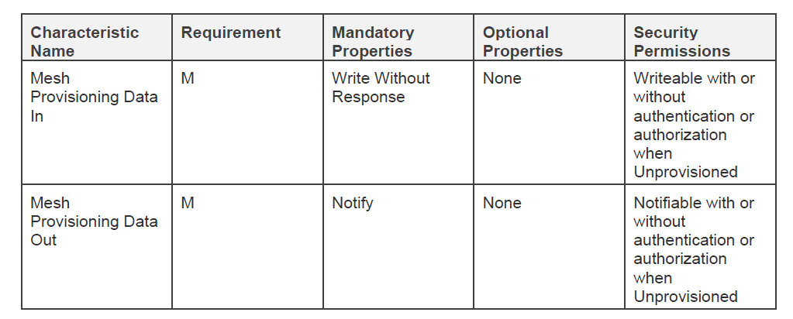

Mesh Proxy Service:

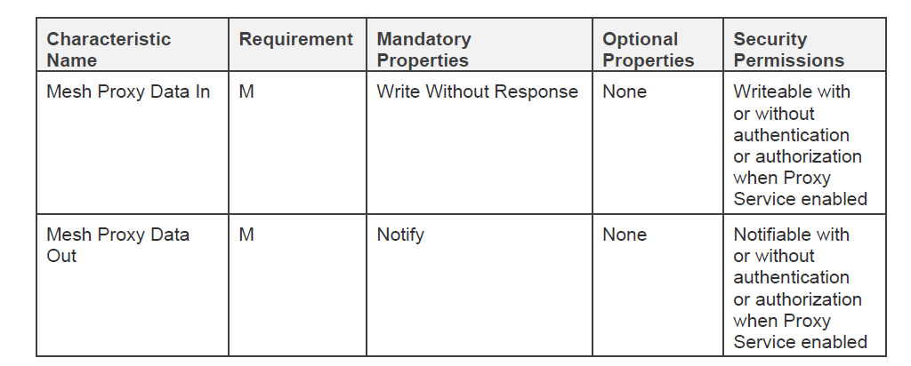

Proxy PDU format
A Proxy Client and a Proxy Server exchange Proxy PDUs. Proxy PDUs can contain Network PDUs,
mesh beacons, proxy configuration messages or Provisioning PDUs.
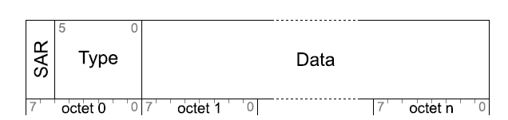

SAR - Message segmentation and reassembly information

Message Type - Type of message contained in the PDU
Data Full message or message segment

License Details
NA For now!

Development Environment

HW Detail
Ubuntu Version: 22.04

Development host
Ubuntu Version: 22.04

Build tools and IDE
Ubuntu Version: 22.04
nRFConnect App

Configurations Supported

Compile time configuration
Kconfig file has multiple configurations compile time. This part will be added during development phase.

Initialization configuration

Runtime configuration

Application API Library

Structures

/* Attribute Information */
struct _attribute {
U16 type;
U16 handle;
U8 *value;
U8 val_len;
};

/* Remote Device Information */
typedef struct{
BDAddr address;
U8 short_name[10];
U8 complete_name[20];
U16 appearance;
U16 conn_handle;
}RemDevInfo;

MACROS
/* To register a Primary Service*/
#define PRIMARY_SERVICE 0x2800

/* To register a descriptor*/
#define DESCRIPTOR 0x2902

/* To register a characteristic*/
#define REG_CHARACTERISTICS 0x2803

/* To register a provision service*/
#define PROVISION_SERVICE 0x1827

/* To register a proxy service*/
#define PROXY_SERVICE 0x1828

/* To register a provisioning data in characteristics*/
#define PROVISIONING_DATA_IN 0x2ADB

/* To register a provisioning data out characteristics*/
#define PROVISIONING_DATA_OUT 0x2ADC

/* To register a proxy data in characteristics*/
#define PROXY_DATA_IN 0x2ADD

/* To register a proxy data out characteristics*/
#define PROXY_DATA_OUT 0x2ADE

8.3 Callback function declarations

8.3.1 gatt_service_cb()

void gatt_service_cb(GATTServerEvent *evt)

Description:
The gatt_service_cb callback function is responsible for handling GATT service events,
including read, write, and notify operations.
Parameters:
A pointer to a GATTServerEvent structure containing information about the event.

8.3.2 global_cb()

void global_cb(GAPEvent *evt)

Description:
This Global callback function is responsible for handling various GAP events, such as
connection establishment, disconnection, pairing completion, and encryption status changes.
Parameters:
A pointer to a GAPEvent structure containing information about the event.

8.3.3 gap_cb()

void gap_cb(GAPEvent *evt)

Description:
The gap_cb callback function is responsible for handling various GAP (Generic Access Profile) events.
Parameters:
A pointer to a GAPEvent structure containing information about the event

Function Declaration

8.4.1 reg_provisioning_service()

void reg_provisioning_service(U16 uuid_val)

Description:
This function is used to register a new GATT service in the GATT database. The function takes a 16-bit UUID value (uuid_val) as its parameter. This UUID value uniquely identifies the GATT service being registered. Here it is registering the provisioning service which is used to provision a device.
Parameters:
U16 uuid_val it defines 16-bit UUID of the service.

8.4.2 reg_proxy_service()

void reg_proxy_service(U16 uuid_val)

Description:
This function is used to register a new GATT service in the GATT database. The function takes a 16-bit UUID value (uuid_val) as its parameter. This UUID value uniquely identifies the GATT service being registered. The Mesh Proxy Service is used to enable a server to send and receive Proxy PDUs with a client.
Parameters:
U16 uuid_val it defines 16-bit UUID of the service.

8.4.3 register_prov_dataout_descriptor()

void register_prov_dataout_descriptor(GATTCharDescInfo *desc_info)

Description:
This is used for registering the descriptor for the mesh data out characteristic of provisioning service. It takes a pointer to a structure (GATTCharDescInfo) as its parameter. The Provisioning Client shall enable or disable notifications to the Mesh Provisioning Data Out Client Characteristic Configuration Descriptor.
This structure contains information about the descriptor The function uses the information provided in the desc_info structure to register the descriptor in the GATT database.
Parameters:
It takes the pointer to a structure that contains the information about the descriptor.

8.4.4 register_proxy_dataout_descriptor()

void register_proxy_dataout_descriptor(GATTCharDescInfo *desc_info)

Description:
This is used for registering the descriptor for the mesh data out characteristic of proxy service. It takes a pointer to a structure (GATTCharDescInfo) as its parameter. The Provisioning Client shall enable or disable notifications to the Mesh Proxy Data Out Client Characteristic Configuration Descriptor.
This structure contains information about the descriptor. The function uses the information provided in the desc_info structure to register the descriptor in the GATT database.
Parameters:
It takes the pointer to a structure that contains the information about the descriptor.

8.4.5 register_prov_mesh_data_in_char()

void register_prov_mesh_data_in_char(U16 uuid, GATTBuf *buf)

Description:
This is used for registering the characteristics for provisioning service. The Mesh Provisioning Data In characteristic can be written to send a Proxy PDU message containing Provisioning PDU to the Provisioning Server.
Parameters:
It takes the 16-bit UUID and pointer to the buffer. Buffer holds the actual data for the characteristics.

8.4.6 register_prov_mesh_data_out_char()

void register_prov_mesh_data_out_char(U16 uuid, GATTBuf *buf)

Description:
This is used for registering the characteristics for provisioning service. The Mesh Provisioning Data Out characteristic can be notified to send a Proxy PDU message containing Provisioning PDU from a Provisioning Server to a Provisioning Client.
Parameters:
It takes the 16-bit UUID and pointer to the buffer. Buffer holds the actual data for the characteristics.

8.4.7 register_proxy_mesh_data_in_char()

void register_proxy_mesh_data_in_char(U16 uuid, GATTBuf *buf)

Description:
This is used for registering the characteristics for proxy service. The Mesh Proxy Data In characteristic is used by the client to send Proxy PDUs to the server using GATT Write Without Response procedure.
Parameters:
It takes the 16-bit UUID and pointer to the buffer. Buffer holds the actual data for the characteristics.

8.4.8 register_proxy_mesh_data_out_char()

void register_proxy_mesh_data_out_char(U16 uuid, GATTBuf *buf)

Description:
This is used for registering the characteristics for proxy service. The Mesh Proxy Data Out characteristic is used by the server to send Proxy PDUs to the client. The server can send a Proxy PDU to the client by executing a GATT Notification procedure on this characteristic.
Parameters:
It takes the 16-bit UUID and pointer to the buffer. Buffer holds the actual data for the characteristics.

8.4.9 handle_start_adv()
void handle_start_adv()
Description:
This callback function is responsible for handling the advertisement, it will start the advertisement.

8.4.10 set_scan_resp()
void set_scan_resp()
Description:
This callback function set the scan response data or advertisement data.

Appendix

About Capgemini
Capgemini is a global leader in partnering with companies to transform and manage their business by harnessing the power of technology. The Group is guided everyday by its purpose of unleashing human energy through technology for an inclusive and sustainable future. It is a responsible and diverse organization of over 325,000 team members more than fifty countries. With its strong 55-year heritage and deep industry expertise, Capgemini is trusted by its clients to address the entire breadth of their business needs, from strategy and design to operations, fueled by the fast evolving and innovative world of cloud, data, AI, connectivity, software, digital engineering and platforms. The Group reported in 2021 global revenues of €18 billion.
Get the Future You Want | www.capgemini.com







This document contains information that may be privileged
or confidential and is the property of the Capgemini Group.
Choose an item. Copyright © 2022 Capgemini. All rights reserved.

